**Tutorial 26: Reaction Timer Game – Reaction Quickness**

In this tutorial we show the user text that will display a message related to how fast their reaction time was when they click the block.

Make sure **Tutorial 25** is complete to be able to move on to this tutorial or clone the [vue3-firebase-course](https://github.com/younggrasshopperza/vue3-firebase-course) repository and go to branch called **Tutorial-25**.

**Step 1:** In the **Results.vue** file, create a data property that returns a variable with a value of null. We then need to update the speed ranking based on the score.

Create a mounted hook that checks the score which we have access to in the prop. So if the score is less than 250 then output a message that is assigned to the speed variable, “Very fast”, otherwise if the score is less than 400 then then output a message that is assigned to the speed variable, “Relatively fast”, otherwise output a message that is assigned to the speed variable, “Not so fast”.

Look at the example below (**Between line 9 and 24**):

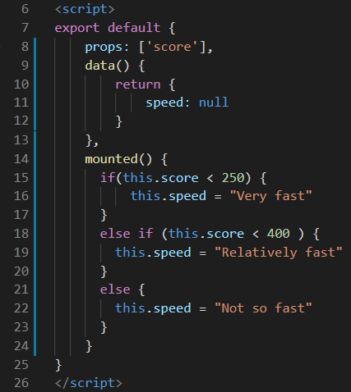

**Step 2:** In the **Results.vue** file, output the speed variable so the user sees what their ranking is according to the speed of how fast they clicked the block. Create a paragraph with a class called speed and display the speed variable.

Look at the example below (**Line 3**):

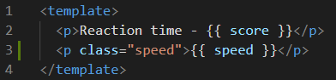

**Step 3:** In the **Results.vue** file, style the speed class by copying the following css code below:

.speed {

      font-size: 1.4em;

      color: #0faf87;

      font-weight: bold;

  }

**Step 4:** In the **App.vue** file, style the button by coping the following css code below:

button {

  background: #0faf82;

  color: white;

  border: none;

  padding: 8px 16px;

  border-radius: 4px;

  font-size: 16px;

  letter-spacing: 1px;

  cursor: pointer;

  margin: 10px;

}

button[disabled] {

  opacity: 0.2;

  cursor: not-allowed;

}

**Output:**

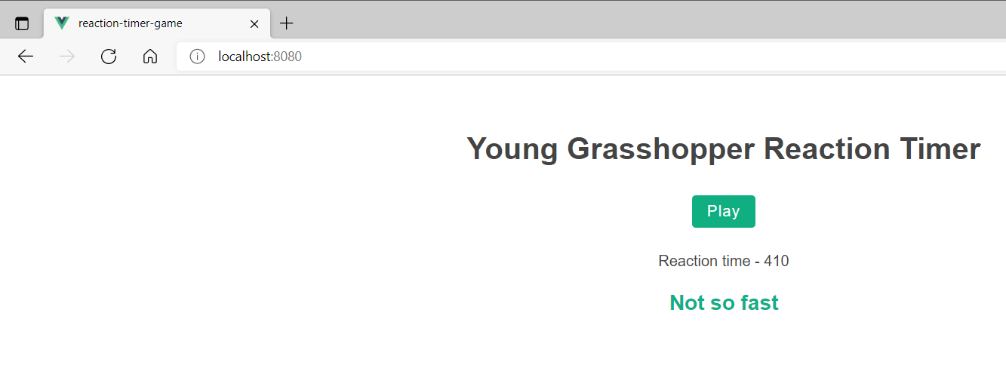

**You can view the code snippets from the** [**vue3-firebase-course**](https://github.com/younggrasshopperza/vue3-firebase-course) **repository under the Tutorial-26 branch**.